ANNA NEWELL:
ARTS GRANT FUND APPLICATION 2027
HOW WE WORK WITH ARTISTS

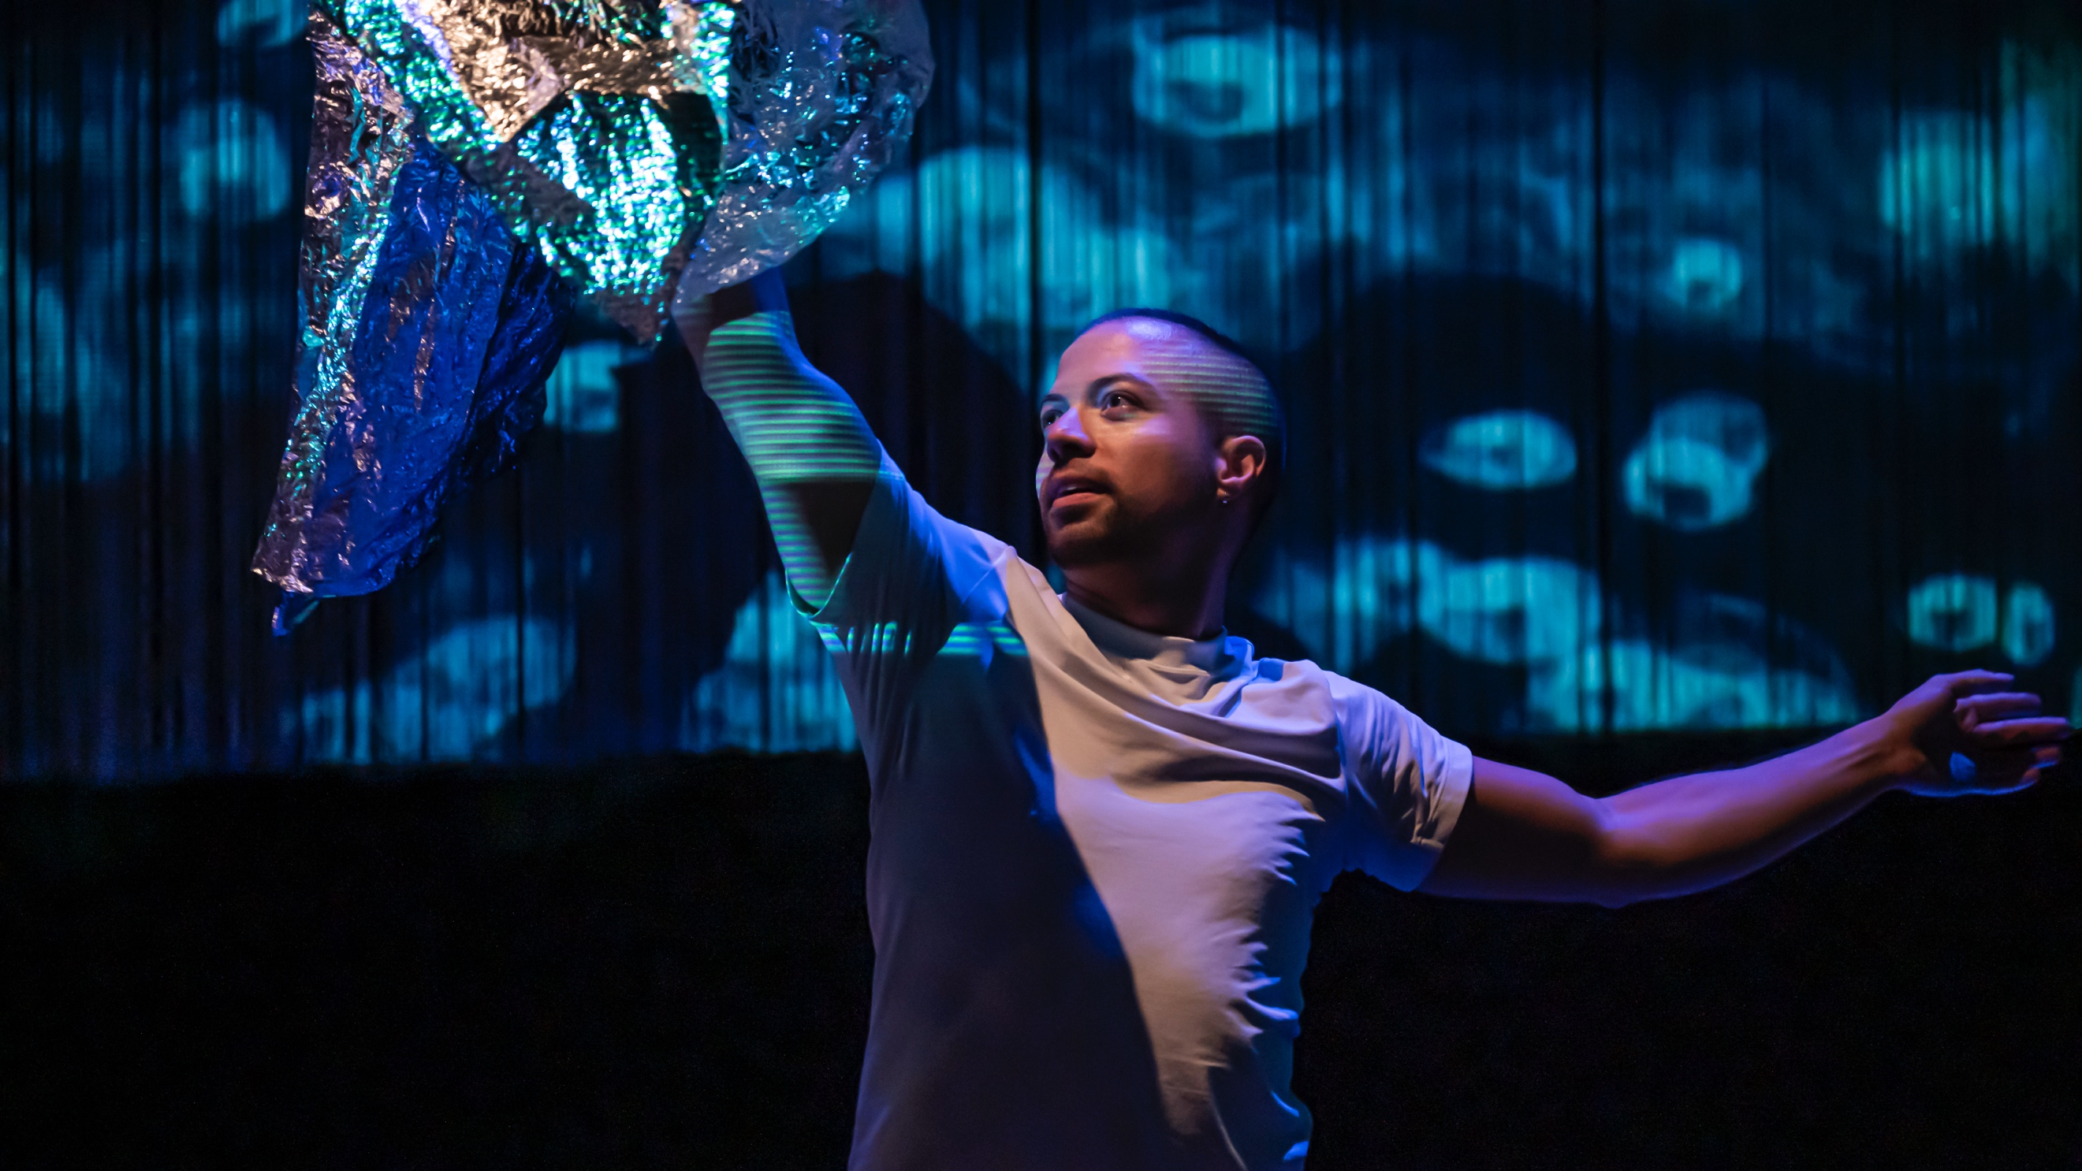

Responsiveness, connection and inclusion is at the heart of the work; and this of course extends to the artists, performers and other staff with whom we work.

Rather than being a static Strategy, this is a deliberately dynamic and iterative process that aims to be open, to engage, to invite ongoing conversation and to respond. We work closely with Niamh Ferry as a freelance consultant (previously General Manager of The Civic and our Exec Producer there and now GM of the National Photographic Museum) who advises us on all our policies and keeps us abreast of all current recommendations and necessary compliances.

It is testimony to our detailed thinking around this that the consultants commissioned by the Arts Council of Ireland to produce their Fair Pay Fair Practice Statement used our policies and, even more crucially, our proven practice as one of their case studies of good practice whilst creating the statement.

Just a few examples of our practices in this context over the past few years are below:

For Up In The Clouds in 2025, we budgeted for ‘away from home’ child-care contribution for our two co-composers who both have young children and, in consideration of both their circumstances and a neurodivergent designer (and considering that all three of them are emerging artists in these particular roles), we budgeted for 3 weeks of development/rehearsal as opposed to the usual, more intensive 2 that we might undertake on this scale of project.

Performers on both tours for 2026 have young families and it continues to be our policy to pay a contribution of €50 per day towards childcare when away from home. For 2027, this is increased to €55 per day.

Each year, we strive to further enhance the working experience for our artists. For 2027, as the tours grow increasingly longer due to demand (our tours for our audiences with complex needs are always over 10 weeks now) and cognisant of the demands on the freelance artist, we are working to ensure that tour dates have sufficient rest breaks to ensure cast health. We are also strictly keeping to a maximum 5-day week (including travel days) and ensuring that there is sufficient room within the schedule of each tour to enable rescheduling should illness occur.

When we have to replace cast members due to illness mid tour, it is our policy to pay the ill cast member for a minimum of 2 weeks sick pay (ensuring that there is sufficient contingency within our budget to enable us to honour this) and have also paid for physiotherapy appointments for dancers and ENT appointments for singers when illness has occurred during rehearsal/touring periods.

We initiated and acted upon conversations with cast members for both of the 2023 tours around how we would facilitate (both logistically and financially) situations where cast members who are parents could have their families join them on tour. These conversations continued on into the 2024 programme and is now part of our core practice when tour planning.

As the demand for the work increases, so the tours become longer. In 2025, we began (particularly with existing work) to have a patchwork of cast members through the tours rather than the same cast throughout. This enables artists who are valuable both to us and to our audiences but who are unable to tour for long periods to continue to be part of our work – and, in the event of illness/injury, we have found that it creates a greater chance that we will be able to find a suitable replacement quicky and easily.

At the suggestion of Julie Kelleher (at the time one of the Network for Extraordinary Audiences venue directors), for littletinySPACE (Arts Grant Funded programme 2022), artists applying for the programme were invited to submit a CV and a letter or a video talking about why they were applying. Offering a video option, it turned out, not only opened up the process to those who might be less confident writing, but actually turned out from our end to be the better option and one that has been adopted for future projects, eg the 2025 Audition Residency.

Similarly, because of pandemic restrictions in 2021, when auditioning for new cast members for babyGROOVE, rather than in-person auditions, we invited potential cast members to learn a piece of music that we sent out to them and then to do a self-tape of this. This is now our standard methodology: as well as avoiding travel costs for potential cast members, it created a much more level playing field so that people could embrace their own learning styles and timescales rather than the previous situation which disadvantaged those who were less confident in the high-pressure situation of an audition room.

For littletinySPACE, all participants were in receipt of a €1000 stipend for the residency (two sets of three days). All of our training or development opportunities for artists within our formal programme will, on an ongoing basis, recognise that, without that kind of financial support, there are artists who would not be able to attend. The two out of 8 artists who were parents indicated that the structure of the residency (two short sets of days) made participation more possible for them as did the artist with an acquired brain injury.

For the Intensive Artist Training programme that I was commissioned to create for Lime Tree | Belltable in late 2024 in partnership with the Limerick CYPSC and St Gabriel’s School, all of the artists received a fee and it is my ongoing commitment that this will be the case for all training opportunities that I lead.

In late 2025, I ran an audition residency based at Sandymount School where artists selected from online application spent 2 days working with myself and with the staff and pupils of the school. They were paid a fee of €500 to cover both these 2 days and their time to travel to our co-producers at Riverbank Arts Centre to present documents for Garda Vetting. One auditionee said “I’ve PAID for training opportunities that haven’t been as good as this!!”

For littletinySPACE 2023, it was indicated to artists that childcare was a valid budget-line as they planned how they spend their allocated mini-R&D-project budget.

This residency was vital to me being able to reconnect with my artistic practice after a challenging lockdown as an artist-parent. It was educational, artistically inspirational, and personally and professionally reaffirming. I feel reinvigorated artistically from this experience and that I can fathom engaging with the theatre sector again.
littletinySPACE participant

Our co-producers at Riverbank Arts Centre and ourselves are fully committed to the principles of SafeToCreate and we actively inform our artists about both this and training opportunities available through SafeToCreate and the existence of Minding Creative Minds. In 2023, we set up the practice of sending pre-rehearsal documents outlining our rehearsal methodology in this context when working with new collaborators.

Through the 6 years of Arts Grant Funding so far, artists working on projects and artists being mentored by myself have included those that are, variously, parents, pregnant, neurodivergent, diverse of heritage, disabled and of the LGBTQ+ community – and our work has, of course, been the richer for it.

